**Parameters for PEA model**

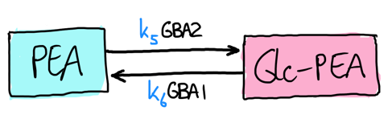Update: 19-5-2022

**GBA1 hydrolysis of GlyNAEs**

**Protocol:**

1. Use 6.8ng recombinant human GBA1 per reaction
2. Add 150mM McIlvaine buffer (pH5.2, +0.1%TX100, +0.2% sodium taurocholate, +0.1% BSA)
3. Add 1/10/100µM GlcNAE mix (GlcAEA/GlcOEA/GlcPEA) or GalNAE mix (GalAEA/GalOEA/GalPEA)
4. Incubate for 0/1/2 hours at 37°C

**Results:**

GlcNAE metabolism by GBA1

KM(GlcAEA) = 161.2µM

Vmax(GlcAEA) = 3.128µM/min

*KM(GlcOEA) = 905.2µM (!) uncertain, because no plateau was reached*

*Vmax(GlcOEA) = 40.84µM/min (!) uncertain, because no plateau was reached*

KM(GlcPEA) = 85.3µM

Vmax (GlcPEA) = 2.970µM/min

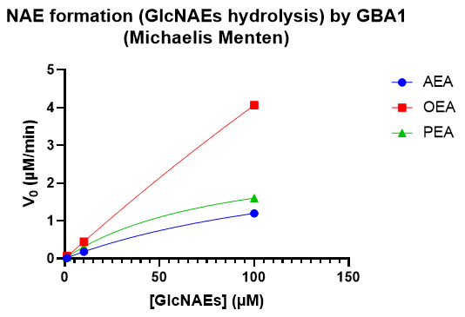

GalNAE metabolism by GBA1

*KM(GalAEA) = (!) uncertain, because no plateau was reached*

*Vmax(GalAEA) = (!) uncertain, because no plateau was reached*

*KM(GalOEA) = (!) uncertain, because no plateau was reached*

*Vmax(GalOEA) = (!) uncertain, because no plateau was reached*

*KM(GalPEA) = (!) uncertain, because no plateau was reached*

*Vmax (GalPEA) = (!) uncertain, because no plateau was reached*

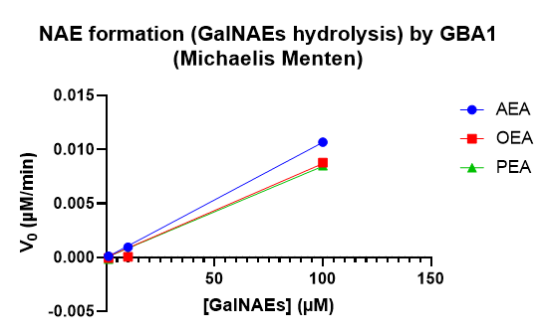

**Discussion:**

Student is planning to repeat this experiment next week, higher concentrations of substrates and only 0/1h incubation (as that seems to be sufficient for determining v0 for each [S]).

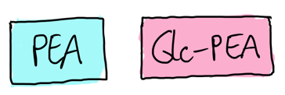**Steady state levels of GlyNAE and NAE levels in RAW264.7 cells**

**Protocol:**

1. Cells were grown to 90% confluency and then harvested (on different days)
2. Measured on LC-MS/MS according to protocol

**Results:**

Steady state levels in RAW264.7 cells

2AG = 6,349±2,525 pmol/mg

AEA = 0,019±0,004 pmol/mg

OEA = 3,110±0,198 pmol/mg

PEA = 0,671±0,015 pmol/mg

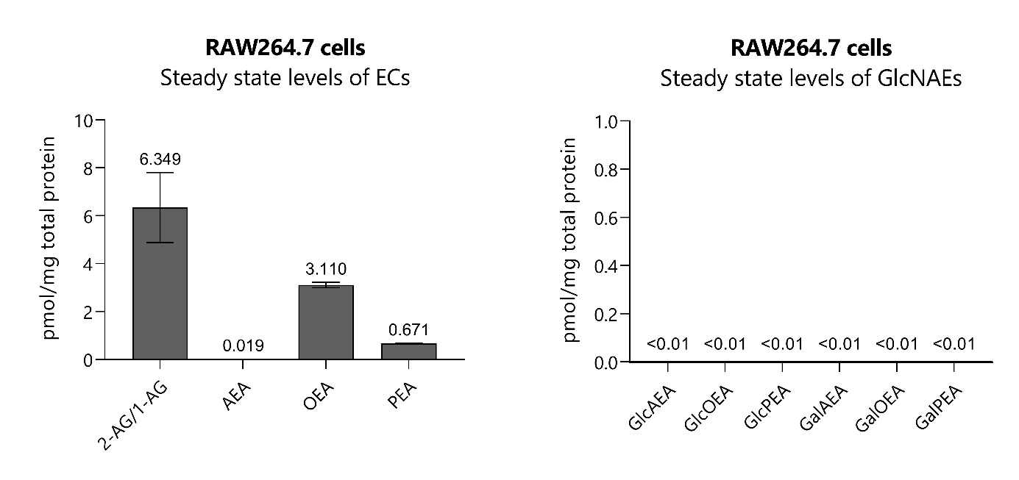

**Discussion:**

Levels of GlyNAEs are below limit of detection. AA, OA and PA have not been quantified for now, but can be quantified if needed?

**Elevation of NAE levels after use of inhibitor**

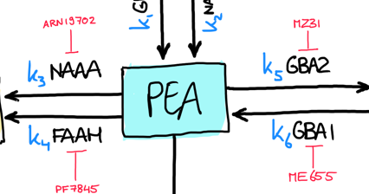

PF044

**Protocol:**

1. Cells were grown to 80% confluency
2. Medium was replaced with 1% FCS DMEM 48h prior
3. At time point, medium was replaced with 1% FCS DMEM with inhibitor cocktail
4. Wash cells twice with PBS
5. Collect cells in 500µL PBS, then spin and freeze
6. Measure pellet on LC-MS/MS according to protocol

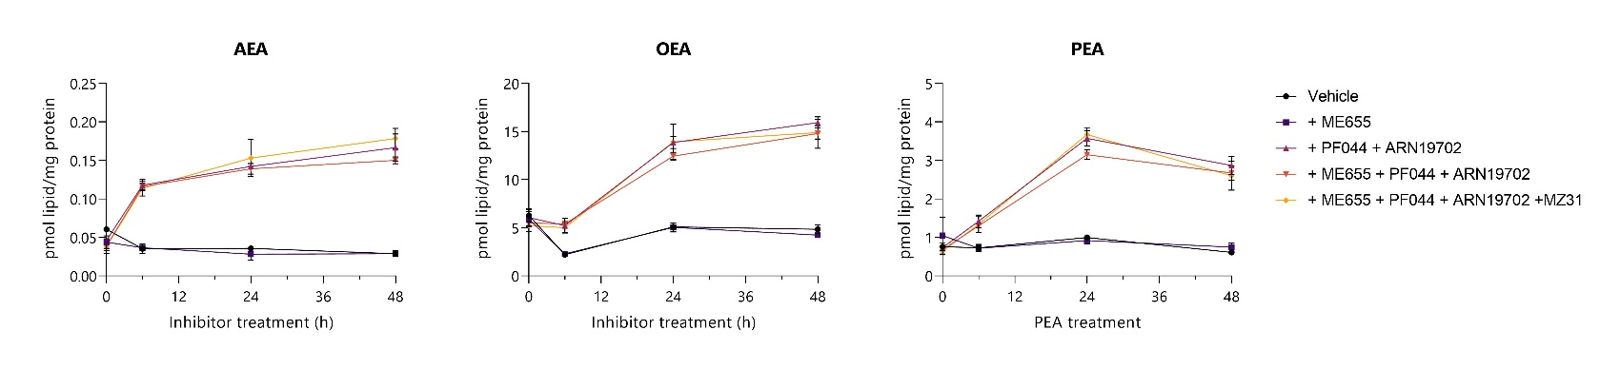**Results:**

Lipid: AEA

|  |  |  |  |
| --- | --- | --- | --- |
| Condition | Time | Average (fmol/mg) | SD |
| Vehicle | 0 | 42,70 | 1,63 |
| Vehicle | 6 | 24,98 | 4,31 |
| Vehicle | 24 | 25,25 | 2,38 |
| Vehicle | 48 | 20,35 | 2,72 |
| + ME655 | 0 | 30,93 | 5,75 |
| + ME655 | 6 | 25,82 | 0,60 |
| + ME655 | 24 | 19,93 | 5,27 |
| + ME655 | 48 | 20,31 | 1,11 |
| + PF044 + ARN19702 | 0 | 32,64 | 1,99 |
| + PF044 + ARN19702 | 6 | 83,13 | 5,37 |
| + PF044 + ARN19702 | 24 | 100,43 | 1,33 |
| + PF044 + ARN19702 | 48 | 117,62 | 12,57 |
| + ME655 + PF044 + ARN19702 | 0 | 27,24 | 6,80 |
| + ME655 + PF044 + ARN19702 | 6 | 81,96 | 3,11 |
| + ME655 + PF044 + ARN19702 | 24 | 98,17 | 4,84 |
| + ME655 + PF044 + ARN19702 | 48 | 106,02 | 3,11 |
| + ME655 + PF044 + ARN19702 +MZ31 | 0 | 26,82 | 3,69 |
| + ME655 + PF044 + ARN19702 +MZ31 | 6 | 80,22 | 6,99 |
| + ME655 + PF044 + ARN19702 +MZ31 | 24 | 107,95 | 17,08 |
| + ME655 + PF044 + ARN19702 +MZ31 | 48 | 125,91 | 9,36 |

Lipid: OEA

|  |  |  |  |
| --- | --- | --- | --- |
| Condition | Time | Average (fmol/mg) | SD |
| Vehicle | 0 | 4432,92 | 509,56 |
| Vehicle | 6 | 1560,92 | 86,31 |
| Vehicle | 24 | 3591,86 | 204,68 |
| Vehicle | 48 | 3413,20 | 336,26 |
| + ME655 | 0 | 4155,73 | 572,15 |
| + ME655 | 6 | 1611,77 | 147,86 |
| + ME655 | 24 | 3556,94 | 325,63 |
| + ME655 | 48 | 2996,77 | 202,02 |
| + PF044 + ARN19702 | 0 | 4275,75 | 593,95 |
| + PF044 + ARN19702 | 6 | 3686,36 | 542,72 |
| + PF044 + ARN19702 | 24 | 9776,82 | 443,66 |
| + PF044 + ARN19702 | 48 | 11244,18 | 230,04 |
| + ME655 + PF044 + ARN19702 | 0 | 3878,45 | 118,08 |
| + ME655 + PF044 + ARN19702 | 6 | 3811,96 | 105,74 |
| + ME655 + PF044 + ARN19702 | 24 | 8780,26 | 280,02 |
| + ME655 + PF044 + ARN19702 | 48 | 10445,94 | 410,11 |
| + ME655 + PF044 + ARN19702 +MZ31 | 0 | 3689,49 | 433,89 |
| + ME655 + PF044 + ARN19702 +MZ31 | 6 | 3537,43 | 360,53 |
| + ME655 + PF044 + ARN19702 +MZ31 | 24 | 9823,98 | 1289,44 |
| + ME655 + PF044 + ARN19702 +MZ31 | 48 | 10516,33 | 1155,16 |

Lipid: PEA

|  |  |  |  |
| --- | --- | --- | --- |
| Condition | Time | Average (fmol/mg) | SD |
| Vehicle | 0 | 536,64 | 73,83 |
| Vehicle | 6 | 513,68 | 64,65 |
| Vehicle | 24 | 705,79 | 46,99 |
| Vehicle | 48 | 431,55 | 49,64 |
| + ME655 | 0 | 739,10 | 339,23 |
| + ME655 | 6 | 506,31 | 58,54 |
| + ME655 | 24 | 648,61 | 64,52 |
| + ME655 | 48 | 529,20 | 79,13 |
| + PF044 + ARN19702 | 0 | 517,96 | 46,41 |
| + PF044 + ARN19702 | 6 | 1002,51 | 114,47 |
| + PF044 + ARN19702 | 24 | 2523,04 | 141,92 |
| + PF044 + ARN19702 | 48 | 1349,48 | 1174,59 |
| + ME655 + PF044 + ARN19702 | 0 | 481,31 | 15,84 |
| + ME655 + PF044 + ARN19702 | 6 | 919,55 | 27,48 |
| + ME655 + PF044 + ARN19702 | 24 | 2223,16 | 88,51 |
| + ME655 + PF044 + ARN19702 | 48 | 1887,25 | 131,48 |
| + ME655 + PF044 + ARN19702 +MZ31 | 0 | 451,72 | 61,50 |
| + ME655 + PF044 + ARN19702 +MZ31 | 6 | 945,25 | 152,21 |
| + ME655 + PF044 + ARN19702 +MZ31 | 24 | 2592,44 | 125,94 |
| + ME655 + PF044 + ARN19702 +MZ31 | 48 | 1836,01 | 266,01 |

**Discussion:**

No effect of MZ31 inhibitor on NAE conc; likely because the amount is very small.

Kinetics of AEA synthesis seem much faster than OEA/PEA; just an observation.

If you need AA/OA/PA again, please contact me and I’ll work on that data as well!